## **Graph elements**

Let’s take a closer look at the two elements that make up a graph:

1. Nodes (also known as vertices)
2. Relationships (also known as edges)

### **Nodes**

****Nodes**** (or vertices) are the circles in a graph. Nodes commonly represent objects, entities, or merely things.

Another example that everyone can relate to is the concept of a social graph. People interact with each other and form relationships of varying strengths.

The diagram to the right has two nodes which represent two people, **Rohit Sharama** and **Virat Kholi.** On their own, these elements are uninspiring. But when we start to connect these circles together, things start to get interesting.

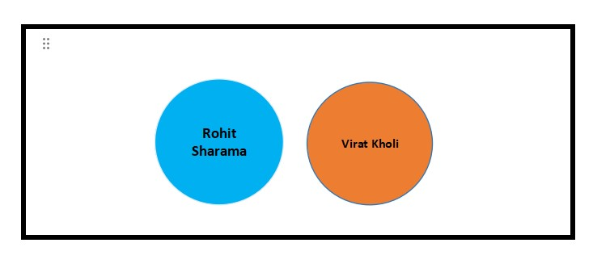

#### **Nodes typically represent things**

Examples of entities that could typically be represented as a node are: person, product, event, book or subway station.

### **Relationships**

****Relationships**** (or edges) are used to connect nodes. We can use relationships to describe how nodes are connected to each other. For example **ROHIT SHARAMA is** the **CAPTAIN** relationship to **INDIAN CRICKET TEAM**. VIRAT KHOLI is the **TEAMATES** relationship to **ROHIT SHARAMA** because both are player of indian cricket team

All of a sudden, we know that we are looking at the beginnings of some sort of social graph.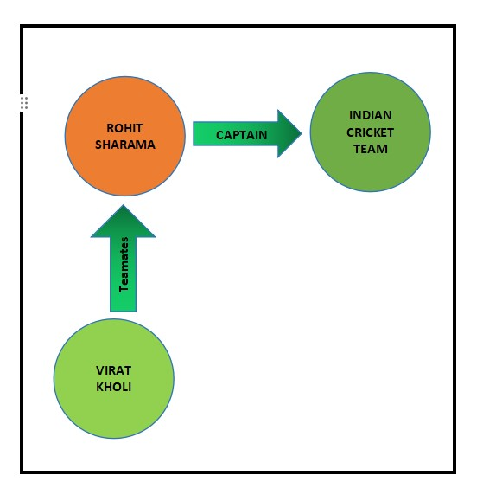

#### **Relationships are typically verbs.**

We could use a relationship to represent a personal or professional connection (Person ****knows**** Person, Person ****married to**** Person), to state a fact (Person ****lives in**** Location, Person ****owns**** Car, Person ****rated**** Movie), or even to represent a hierarchy (Parent ****parent of**** Child, Software ****depends on**** Library).